Legislating Multiculturalism – A Case for a National Multicultural Act?
Delivered by Dr Sev Ozdowski OAM FAICD, Chair of the Australian Multicultural Council at the FECCA national biennial conference, Sydney on 5 November 2015.
“There is no doubt that Australia is one of the most diverse nations on earth; yet our social cohesion and community harmony remain high. The key to our success has been our commitment to giving everyone a fair go and maximising the benefits of our diversity.
Indeed it is our multiculturalism that has contributed to Australia’s success both economically and socially. … It is therefore reasonable to consider whether multiculturalism should be legislated at the national level. … The question at the heart of this issue is whether or not legislating multiculturalism would result in positive change.”
Legislating for multiculturalism
“There are a number of examples where legislation was enacted to deal with aspects of multiculturalism. …
…internationally, the most quoted example … is the Canadian Multiculturalism Act 1985. The principles espoused … include equality, participation and inclusion among others … [and the legislation also] affirms the government’s recognition of the benefits of diversity.
In Australia, New South Wales (NSW), Victoria and South Australia have specific multicultural legislation in place.
Western Australia enacted a Multicultural and Ethnic Affairs Commission Act in 1983; this was repealed in 2006.
A new Multicultural Recognition Bill was introduced into the Queensland Parliament on 27 October 2015.
Taking as an example the NSW Community Relations Commission and Principles of Multiculturalism Act 2000 (the Act) - six principles of multiculturalism are established as the policy of the state:
- The people of NSW … are free to profess, practise and maintain their own linguistic, religious, racial and ethnic heritage;
- All individuals in NSW … should demonstrate a unified commitment to Australia, its interests and future and should recognise the importance of shared values governed by the rule of law within a democratic framework;
- All individuals in NSW should have the greatest possible opportunity to contribute to, and participate in, all aspects of public life in which they may legally participate;
- All individuals and institutions should respect and make provision for the culture, language and religion of others within an Australian legal and institutional framework where English is the common language;
- All individuals should have the greatest possible opportunity to make use of and participate in relevant activities and programmes provided or administered by the Government of NSW; and
- All institutions of NSW should recognise the linguistic and cultural assets in the population of NSW as a valuable resource and promote this resource to maximise the development of the state.
The Act also creates the Community Relations Commission For a multicultural NSW to fulfil a range of functions … To support the Commission’s work, the Act also provides for the establishment of Regional Advisory Councils covering all regional areas of the state.
The principles of multiculturalism established by the Act … requires government agencies to develop plans to show how they will conduct business within a culturally, linguistically and religiously diverse society. Under the state’s annual reports legislation, agencies are also required to report publicly on their multicultural performance through their annual reports. …
While NSW, Victoria and South Australia are the only Australian states with specific multicultural legislation in place, other states and territories have anti-discrimination and human rights legislation which include multicultural considerations. … Additionally, the Australian Capital Territory and Victoria have enacted human rights acts that support their broader multicultural frameworks.
All states and territories have in place policies and coordinating agencies for multiculturalism.”
Common aspects of legislation & policy
“When we look at the countries and states that have legislated multiculturalism, there are generally some consistent aspects of the legislation:
- general principles of multiculturalism
- access and equity principles, and
- provision for government to establish an independent advisory body or commission.
These aspects … are broadly present in current policy and practices at the national level. In fact, successive Australian governments have demonstrated a commitment to a multicultural Australia since the 1970s, through:
- multicultural agendas or statements such as the Galbally principles (1978), Hawke’s National Agenda for a Multicultural Australia (1989) or Howard’s New Agenda for Multicultural Australia (1999) or Gillard’s The People of Australia statement (2011)
- access and equity policies
- support for multicultural advisory bodies, such as the Australian Multicultural Council, and
- measures such as SBS, support for languages, [and] community grants.
This commitment demonstrated by governments has withstood various threats (real or perceived) to our social cohesion, including the Pauline Hanson One Nation movement, overseas unrest and economic downturns. Policies have been created to allow flexibility and delivery in accordance with the views of successive governments and the strategic directions of different times. However, the general principles have remained consistent.”
Current legislative mechanisms
“There are also various checks and balances in the current legal system to ensure the continued protection and implementation of our multicultural principles.
Internationally, Australia is a party to the seven key human rights treaties:
- The International Covenant on Civil and Political Rights
- The International Covenant on Economic, Social and Cultural Rights
- The Convention on The Rights of The Child
- The Convention on the Elimination of All Forms of Discrimination against Women
- The Convention on the Rights of Persons with Disabilities
- The Convention on the Elimination of All Forms of Racial Discrimination, and
- The Convention against Torture.
Discrimination on the basis of age, disability, race and sex is unlawful under federal legislation as set out in the: Age Discrimination Act 2004; Disability Discrimination Act 1992; Racial Discrimination Act 1975; and Sex Discrimination Act 1984.
The Australian Human Rights Commission has statutory responsibilities to investigate and conciliate complaints of alleged discrimination and human rights breaches lodged under these laws.
The themes of multiculturalism are also embedded in the Australian Citizenship Act 2007 under which “Australian citizenship is a common bond, involving reciprocal rights and obligations, uniting all Australians, while respecting their diversity”, and in other legislation.
Although it needs to be acknowledged that regrettably Australia does not have either a constitutional or legislative bill of rights, Australia’s constitution includes a small number of limited rights, including: the right to vote (section 41); the right to a trial by jury (section 80); freedom of religion (section 116); and others. In addition, as mentioned earlier, various states and territories have successfully implemented multicultural acts and human rights bills.
However, at the national level, successive governments did not appear to see the necessity to create a multiculturalism act mainly due to the architecture that is already in place.”
Policy advantages
“Some people would argue that there are … advantages to having our multicultural principles established in policy rather than legislation:
- Australian multiculturalism is not ideology but simply a set of government policies and programs that aim at effective integration of migrants and refugees to achieve egalitarian, economically robust and politically inclusive society
- policies and practices can change depending on the strategic directions of different times
- policy allows for a degree of flexibility and adaptability that cannot be found with legislation, and there is a
- reduced level of red tape and reporting which ensures that efforts are focused on improving outcomes.”
Support for multiculturalism.
“They also would point out that support for multiculturalism is more or less constant and that at a national level genuine commitment by Australian governments will not be achieved through legislation. The government’s commitment to multiculturalism is present because of the success of and public support for Australian multiculturalism.
The Scanlon Foundation’s research into social cohesion in Australia has found that 85 per cent of people agree that cultural diversity is good for Australia. The [2015] survey showed that 93 per cent felt a strong sense of belonging and 89 per cent expressed a sense of pride in the ‘Australian way of life’.
Furthermore, our cultural and linguistic diversity is considered an asset and source of great social and economic strength. In 2014, the Migration Council of Australia reported that by 2050 migrants are estimated to contribute $1.6 trillion per annum to the Australian economy.”
Conclusion
“There would obviously be some advantages and some disadvantages in having a national Multicultural Act. National multicultural legislation would demonstrate Australia’s support for multiculturalism.
However, at the national level there is already legislation and policy in place that is successfully supporting the principles of multiculturalism and maximising the benefits of our diversity to our society. Furthermore, Australia has a long history of supporting multiculturalism and the Scanlon Foundation’s research shows that this support remains stable under the current system.
Due to the success of the current national system, there is little political will to legislate in this area. If we decide to go for the establishment of an Australian Multiculturalism Act, timing would be also of importance.”
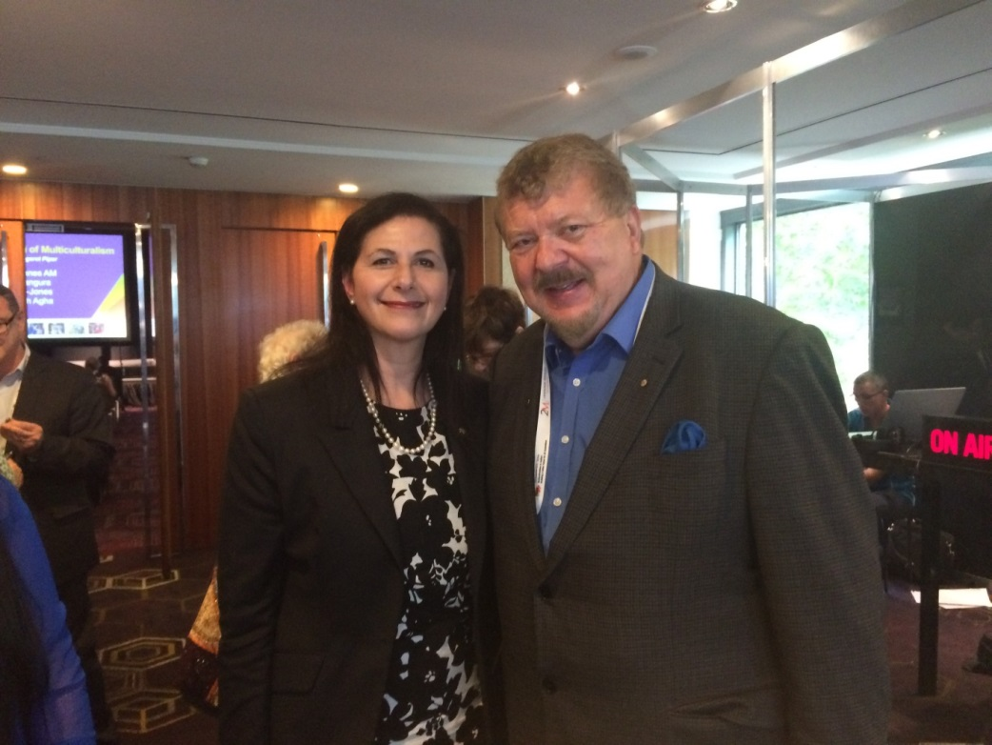
Assistant Minister for Multicultural Affairs Senator the Hon Concetta Fierravanti-Wells with Dr Sev Ozdowski OAM FAICD at the FECCA 2015 National Biennial Conference in Sydney on 5 November 2015.

