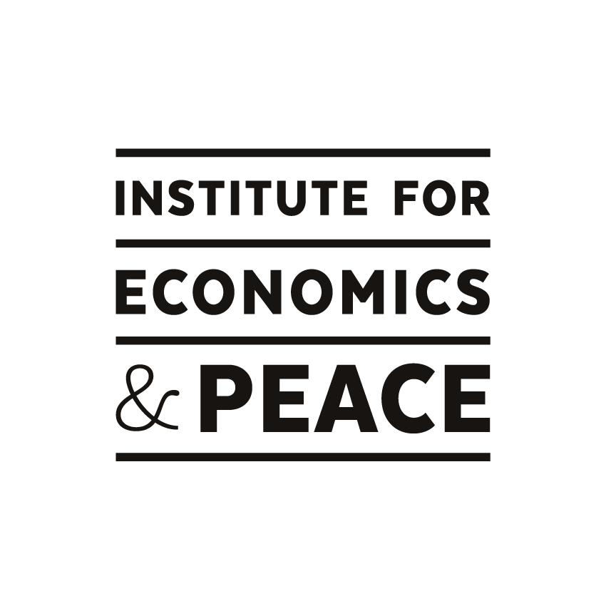

IEP Country Risk Analysis Product

1) IEP Background

Institute for Economics and Peace (IEP) is the world’s leading think tank dedicated to developing metrics to analyse peace and to quantify its economic value. It does this by developing global and national indices, calculating the economic cost of violence, analysing country level risk and understanding positive peace. The research is used extensively by governments, academic institutions, think tanks, non-governmental organisations and by intergovernmental institutions such as the OECD, The Commonwealth Secretariat, the World Bank and the United Nations. The Institute was recently ranked in the top 15 most impactful think tanks in the world on the Global Go to Think Tank Index.

Institute’s intellectual properties Global Peace Index (GPI), Positive Peace Index (PPI) and Global Terrorism Index (GTI) provide solid and unique foundation to measure the international peacefulness of 162 countries. It has raised significant awareness about the drivers and indicators of peace and become a valued resource used by academics, intergovernmental organisations, and governments around the world.

In an effort to make peace a more central area of study, for students, teachers and academics, the Institute for Economics and Peace works with a growing network of schools and universities globally. At the Primary and Secondary level, we have developed a range of resources for teachers to introduce peace into the classroom across a number of subjects. At the tertiary level, we are working with academics and universities, including business schools and economics departments, to develop deeper research into peace and its value within society.

The institute’s research is used in university courses worldwide, in fields including management, business, economics, criminal justice, conflict resolution and international affairs. In order to further our understanding of the linkages between business, peace and economic development, IEP has created the Business Faculty Network, a consortium of business faculties and scholars. We periodically host academic conferences.

2) IEP Country Analytic and Risk Product

IEP is developing a cloud based country analytic and risk assessment software product to offer to academic institutions, multi-lateral organisations, governments and businesses to enable them to easily craft country based analytics.

IEP country analytic product will have below key features.
- Cloud based Architecture supporting SaaS subscription model.
- A simpler and user friendly interface to provide an easy, memorable and meaningful interaction for customers.
- Enable quantitative analysis and comparison of IEP risk indicators
- Ability to create, modify, update and delete indexes, country profiles and risk models.
- Access to pre-defined IEP indexes, risk models and country profiles.
- Compare and evaluate indexes using data visualization techniques i.e. bar charts, pie charts, time series, scatter plots, histograms etc.
- Ability to generate customized country analytic profiles by analyzing a large range of indicators including economics, society, peace, conflict and violence.
- Identify a country’s risk of falling in GPI, PPI or GTI rankings.
- Identify a country’s level of societal resilience based on prior empiric research
- Enable academics to compare cross country socio-economic data, and help find correlation between risk indicators.
- Upload client data or modify IEP data to better understand the flow on effect of changes.
- Download client analysis into a pdf, jpeg, png or excel format.
- Allow users to register for 1 month trial or a multi-year subscription membership.
- Regular data updates to IEP datasets.

2.1) Benefits

The key product benefits are
- Simplicity – Automates complex statistical analysis and saves academics and students time on manually updating spreadsheets and graphs to include in their analysis and research.
- Advanced Country Analytics – Hundreds of data views, indexes and country profiles.
- Superior Risk Analysis – Unique research methodology to forecast systemic country risk using IEP risk models.
- Superior Opportunity Analysis – Enable probability measures for which countries will have
the potential for sustained long term future growth.
- Streamlined country information – Hundreds of pre-defined views of country risk data
- Unique Data – Access to IEPs original data combined with other data statistically transformed into knowledge.

2.2) IEP Research Data

IEP has one of largest harmonised country based datasets in the world with over 8,900 different indexes, attitudinal surveys and dataset, as well as IEPs own unique datasets and analysis which is considered some of the world’s leading research on peace research. The product will enable academics, students and researchers access to our acclaimed research in the areas of economics and peace studies.

Our research team is highly skilled in quantitative techniques and specialised development of indicators and composite indices related to global peace, conflict, and violence.

The institute’s studies into finding linkages between economy and peace are well defined, well regarded and unique. IEP analyses over 8,900 different indices, datasets and attitudinal surveys in conjunction with current thinking about the drivers of violent conflict, resilience and peacefulness. The extensive data coverage of world’s 99.6 % population is harmonized and stored in a common database.

The combination of IEP’s datasets, along with the other data that it has sourced provides an excellent baseline set of data suited to undertake holistic and empirical studies to identify the positive factors which create and sustain peaceful societies.

The institute believes this data is of great value to researchers, academics and students globally interested in peace studies. IEP plans to make our research data available to academic institutions and libraries.

Institute holds data for below categories

Datasets | Indicators
Economic | - Macroeconomics  - Finance  - Government Budget  - Infrastructure
Conflict & Violence | - Militarization  - Diplomatic Relations  - Terrorism  - Safety & Security  - Ongoing conflict
Political | - Governance  - Respect for human rights  - Political institutions  - International Relations
Societal | - Education  - Health  - Social Capital  - Attitudinal  - Inequality
Geographic | - Natural Resources  - Natural Disasters  - Ecological  - Metrological
Demographic | - Ethnicity  - Population  - Religion

IEP Research Committee
- Professor Jurgen Brauer, Professor of Economics at Georgia Regents University’s James M. Hull College of Business;
- Professor Kevin P Clements, Foundation Chair of Peace and Conflict Studies and Director of the New Zealand Centre for Peace and Conflict Studies at the University of Otago, Dunedin New Zealand and Secretary General of the International Peace Research Association;
- Associate Professor Benjamin Goldsmith, Associate Professor in the Department of Government and International Relations at the University of Sydney;
- Professor Jennifer Oetzel, Associate Professor of International Business, Kogod School of Business
- Francesco Mancini, Senior Director of Research, International Peace Institute
IEP’s International Advisory Council Members
- Dr Sabina Alkire, Director, Oxford Poverty and Human Development Initiative
- Rt Hon Lord Brown of Ladyton, Chair of the European Leadership Network and Former UK Secretary of State for Defence & Scotland
- Prof. Tilman Bruck, Distinguished Senior Fellow, Stockholm International Peace Research Institute
- Maria Cattaui, Former Secretary-General of the International Chamber of Commerce;
- Dr Scilla Elworthy, Founder, Peace Direct and Oxford Research Group
- The Hon Gareth Evans AO QC, Chancellor, Australian National University and former Australian Minister for Foreign Affairs
- Prof James Galbraith, Lloyd M. Bentsen, Jr. Chair in Government/Business Relations LBJ School of Public Affairs, The University of Texas at Austin
- Jeremy Gilley, Founder, Peace One Day
- Kerry Kennedy, President, Robert F. Kennedy Center for Justice and Human Rights
- Ian Kortlang, Chief Executive, 360m-Media Insight
- Prof John Tepper Marlin, Principal at CityEconomist, and Adjunct Professor, Stern School of Business
- Sir Mark Moody-Stuart, Chairman, Foundation for the UN Global Compact, and former Chairman of Anglo American plc.
- Dr Daniel Shapiro, Director, Harvard International Negotiation Program
- Dr David Stevens, Global Lead: Project Optimisation, Parsons Brinckerhoff, Global Mining
- Dr William Vendley, Secretary-General, Religions for Peace

Global Peace Index (GPI) Expert Panel

- Professor Kevin P. Clements, Chairperson, Foundation Chair of Peace and Conflict Studies and Director, National Centre for Peace and Conflict Studies University of Otago, New Zealand
- Dr Sabina Alkire, Director, oxford Poverty & Human Development Initiative (OPHI), university of Oxford, United Kingdom
- Dr Ian Anthony Research Coordinator and Leader of the Arms Control and Non-proliferation Programme, Stockholm International Peace Research Institute (SIPRI), Sweden
- Mr Vasu Gounden, Founder and Executive Director, African Centre for the Constructive Resolution of Dsiputes (ACCORD), Durban
- Mr Nick Grono, CEO the Freedom Fund, London, United Kingdom
- Dr Manuela Mesa Director, Center for Education and Peace Research (CEIPAZ) and President, Spanish Association for Peace Research (AIPAZ), Spain
- Dr Ekaterina Stepanova Head, Unit on Peace and Conflict Studies, Institute of the World Economy & International Relations (IMEMO) Russian Academy of Sciences, Russian Federation

