**Feedback provided by students of Year 6 Opportunity Class of Kingswood Public School on lecture about importance of human rights delivered by Dr Sev Ozdowski OAM of UWS on 5 May 2014**

Dear Dr Ozdowski,

Human Rights are rights inherent to all human beings, whatever our nationality, place of residence, gender, national or ethnic origin, colour, religion, language or any other status. We are all equally entitled to our human rights without discrimination. These rights are all interrelated, independent and indivisible.

When I discovered that Doctor Professor Sev Ozdowski was going to present a lecture on Human Rights, I was so extremely thrilled as I love the United Nations and would love to work there in the upcoming future. Doctor Professor Sev Ozdowski started my favourite lecture by asking S3D where we believed he came from. He was raised in Poland, had been a refugee for two years in Germany and following this, he moved to Australia. We then shared our own nationalities and heritage with the rest of the class.

World War Two, also known as the Second World War, was a global war that lasted from 1939 to 1945, though some related conflicts in Asia began before this date. It involved [the vast majority of the world's nations](http://en.wikipedia.org/wiki/Participants_in_World_War_II)—including all of the [great powers](http://en.wikipedia.org/wiki/Great_power)—eventually forming two opposing [military alliances](http://en.wikipedia.org/wiki/Military_alliance): the [Allies](http://en.wikipedia.org/wiki/Allies_of_World_War_II) and the [Axis](http://en.wikipedia.org/wiki/Axis_powers). It was the most widespread [war](http://en.wikipedia.org/wiki/War) in history, and directly involved more than 100 million people, from more than 30 different countries. World War Two was thought to have been the deadliest conflict in human history. In the Second World War there was a vast amount of discrimination. Doctor Professor Sev Ozdowski told S3D that the Concentration Camp handlers split their ‘prisoners’ into groups such as, disabled and Jewish people. The Concentration Camp people killed these innocent human beings.

The United Nations officially came into existence on the 24th of October 1945, when the United Nations, otherwise known as the UN Charter had been ratified by a majority of the original fifty-one member states. This day is now celebrated around the world as United Nations Day. The purpose of the UN is to bring all nations of the world together to work for peace and development, based on the principles of justice, human dignity and the well-being of all people. It affords the opportunity for countries to balance global interdependence and national interests when addressing international problems.

United Nations was formed in 1945 at the end of the Second World War, along with Human Rights. There are many different types of Human Rights such as Economic Rights, Women Rights, Sexism Rights, Child Rights, Health Rights, Slavery Rights, Equality Rights, Segregation Rights and Political Rights. An example of a health right is that everyone should have the right not to be discriminated against. This means discrimination can be indirect or direct, this right does not apply on its own. An individual can only use the Human Rights Act to argue discrimination if another human right is breached. However, the right not to be discriminated against, may have been breached under other legislation such as the Disability Discrimination Act 1995. Some examples of relevant issues are access to medical treatment or community care services, based on age, disability, gender or ethnic origin. Failing to offer food to take into account of cultural or religious differences, such as kosher or halal foods, can be seen to some people as a form of discrimination.

I discovered that Australia started Economic Rights before any other country in the world.

Another major issue in our world is segregation. Segregation is the action or state of setting someone apart from others. In the past, this has been a major global issue. There has been segregation with gender or otherwise also known as sexism, and segregation with the colour of ones’ skin. For example in the past, “white” and “black” people had to sit apart on buses and had different shops and basically, lives.

Doctor Professor Sev Ozdowski, went on to state “Some rights are absolute and some are more negotiable.”

For a while we talked about the First Fleet. Professor Sev Ozdowski, asked S3D who Redfern was. We answered his question by saying it was a suburb. He explained that Redfern was a great doctor. Doctor Professor taught us that even if you are the ‘underdog’ or have done something wrong, you can rise to any occasion and have an amazing career and life. Redfern proved that you can turn your life around dramatically.

We talked about how Australia is the only legal system not to have a Bill of Rights. It is the only Western democratic country with neither a constitutional nor Federal Legislative Bill of Rights to protect its citizens.

Overall, I thoroughly enjoyed the high-quality lecture. I hope to have a connection with the United Nations and Human Rights in the near future.

Amelia

Dear Doctor Sev Ozdowski,

I really loved your intriguing lecture yesterday at 10 o’clock (5th of May). At the beginning of the school day our teacher, Mrs Dunstan, told everyone that we were going to have a lecturer coming and talking to us about human rights. There were some ‘awws’ going in the air, but I had no problem with it. I looked up at the board and saw it. “Doctor Sev Ozdowski, 5th of May”. I noticed your surname ‘Ozdowski’ and I saw that your surname ended with ‘ski’. I knew that you had come from Poland.

In your lecture you taught us many things, such as that before 1945 Germans (during those times known to be Nazis) and Russians took innocent people to concentration camps and forced them to work, if they could not work or refused to work they would get shot. Then in 1945 countries all over the world came together and pledged to give people rights. We now have the rights to learn, vote, work and get paid a minimum wage or higher. Thank you for your amazing lecture and I hope you go well with all your other lectures and work. Once again, Thank you. Sincerely, Michael Zylka S3D  
  


Dr Sev Osdowski,

There are many rights that have been formed in our country or worldwide. These rights were formed in this world to make it grow with the people who live in it.

There are rights such as –

* Political rights
* Economical rights
* Gender rights
* Social rights

Gender rights and social rights are very important to have these days, for the reason that not many people are being fair to other races, genders or who someone is as a person.

In World War II, depending on what race you belong to and your social status you were to be killed. For example if you just looked like a certain culture that someone doesn’t like you were to be killed or sent to a concentration camp.

In the year *1902* the Commonwealth Franchise Act extended the vote to women. That was 112 years ago and rights for women are still improving.

Later in the year, *1984* the Federal Sex Discrimination act gave effect to the International Convention on the Elimination of all forms of Discrimination Against Women ( CEDAW ). Equal Opportunity Acts introduced in Victoria, WA and SA.

Thank you for giving S3D an insightful lecture on Human Rights.

Paavana



Dear Dr Sev Ozdowski,

Your interesting and engaging lecture left me thinking about how racial discrimination and human rights separates people. Luckily, in Australia and many other countries, there is multiculturalism, human rights, women’s rights, children’s rights, political rights and economic rights. In other countries such as Poland, were invaded by Russia and Japan. Innocent citizens in Poland had to suffer in concentration camps where most were killed and some were shot while tied to poles.

As you had said the main problem that we still have to solve is segregation. Segregation is when people are separated because of their skin tone, culture, background or even gender. I believe that we should all have the access to women’s rights, children’s rights, political rights and economic rights and most important of all, human rights. Yours sincerely, Annisha

Dear Prof Sev

Your lecture on human rights enlightened my class and I on this very concerning issue. Human rights is a topic that affects everyone, whether black or white, male or female, rich or poor; everyone is affected by human rights…

I was particularly interested in your story about how Canberra was formed, and how Australia has a different legal system originally from New Zealand, but everything you said proved fascinating. One thing you answered for me was a question that always bugged me…when was the United Nations formed? Only now do I know it happened after WW2… I could tell you but a lot of effort into this lecture from the timeline papers and award.

Human rights, I think is a matter more people should be talking about, as not everyone is as fortunate as we are in Australia! On behalf of our class I thank you for speaking to us on this fascinating subject…

Angus 

Dear Prof Sev,

I hope this email is able to represent my absolute gratitude for such an interesting and entertaining lecture about human rights and humans themselves.

Throughout this lecture, you noted an extraordinary amount rights humans as a global society should be able to receive, which included:

* Women’s Rights
* Child’s Rights
* The Right to Live Fear Free
* Racial Rights
* Wage Rights

These rights are in place and yet, every day, we see them being cast aside with situations such as; men being separated from women at audiences to children being torn away from their own families, and why. Maybe it’s because a person or group of people have a belief that they are the most powerful race of humans in the world and that all other races are inferior, so they start making them slaves, killing loved ones, torturing people to the point they wished they had never been born.

A great yet saddening example of this type of person is the chaotically aggressive Adolf Hitler (who has an interesting story), and how he killed 6 000 000 Jews because of one problem in his childhood … he didn’t get into a Jewish Creative Arts School. So he then started making up horrible rumours about his own childhood and how the Jews were to blame, and soon amassed a catastrophic catastrophe of a German army.

So maybe having rights in place won’t stop bad things happening, but they do let us recognise when bad things are happening, so we can confront places like North Korea (if you’ve got the bravery for it) and tell them what they’re doing is wrong but don’t state which country you’re from or your airplane trip might take you back to a blackened pile of smouldering rubble and the faint green glow of nuclear radiation. -Jeremy

Dear Dr Sev Ozdowski.

It was an honour to learn about this merciless topic from a truly experienced person and I, personally, thank you for all of your effort put into your philosophical views with baffling details. I truly have learnt a vast amount of extremely beneficial knowledge of this important matter. And I shall confirm, everyone in our grateful class, S3D, was greatly absorbed by your very detailed and imaginative lecture.

Racial and cultural injustice was like a wide-spread disease, seemingly unstoppable and no hope for a cure, it devastated many people. It was extremely captivating learning about human rights and the mystifying history behind it. As I looked around the room I felt a flurry of questions and saw hands shooting into the air with eagerness and anticipation, your illuminating speech truly baffled me and caused us to amplify our own personal views with enthusiasm.

I must deeply thank you for a great learning experience on a topic that our class is truly grateful for, as we are doing research on an almost identical topic. This experience has motivated and bewildered me and I hope you can teach other lucky students so everyone is conscious about this infamous issue.

Jason 

Dear Dr Sev Ozdowski,

Your lecture had an amazing amount of interesting facts and points about human rights and initiated the topic with a question to our class about which country we were from. It was a wonderful mix of facts, and surprisingly, a very intriguing section of history that some might not have noticed if not for some of the obvious things, like how Redfern, a suburb that is close to Sydney’s CBD, was named after a famous released convict, William Redfern. William Redfern was released, then turned over a new leaf and grew to be a renowned surgeon and then a judge. The lecture was thought provoking, and when it began I thought hard. I thought about human rights, I thought about the wars and concentration camps, and I thought about why my name tag kept falling off.

In the time surrounding the two world wars, the conditions of criticism were in dire need of repair. Criticism is countries bullying others because of their behaviour or political or economic decisions. Criticism is not to be tolerated, not for people, not countries, nor organisation or anyone else. I had no idea that concentration camps were made to torture and sometimes kill homosexual people and disabled people because they couldn’t work besides different religious people and priests. The main point of the speech, human rights, was explained almost perfectly, with most of the details being explained to make the topic crystal clear. We have many rights, like the right to education, freedom of speech, voting rights and the right to be treated as an equal to every-one else. This means to not be treated to racism or sexism, and one thing most people know of, to treat others the way you would like to be treated. It was understood that the women’s voting rights were first established in New Zealand in the year 1893, and were also made a right around the world in the years soon after. The definition of a human right is a rule that people have to obey which is often for their own good. Many charities have been brought up by the world to help make more human rights or help keep them going. Not all segregation is unfair and cruel, like people with different coloured skin should not be allowed in the same roll segregation is unfair and mean 1893. know of, to treat others the way you would like to om, or vehicle. Some of the less unfair segregation is like boys and girls toilets and areas with different age groups. If a single person in a group of hundreds is a criminal, it does not mean that the whole crowd is unkind and evil. The police could put the one person in jail, or interrogate a whole crowd to waste their time. The same goes for segregation. Say the criminal was gender inequality, or racial prejudice, and the rest of the crowd were good things like girls and boys toilets or different age groups in different learning facilities, so the charities and things could try to stop just the bad segregation, or all segregation altogether!

In a world where there were no rules, no rights, no laws on segregation, or no peace keepers, the world would be absolute chaos and mayhem. People would be running amok and hurting others when they felt like it or throwing people out windows and swearing racist and sexist comments. A person could be rich one moment by winning the lottery and poor the next because someone took all the winnings. Banks would be penny-less, and criminals would be richer than Bill Gates, who would be poor because of thieves and pick pockets. There would be no one to stop all of this, because governments and police would not exist. My point is, rights, rules and segregation laws are the links in a chain, or a tongue of a frog. People would not be likely to survive if one did not have these three things to keep society going.

Sincerely, Sarvam Khanna 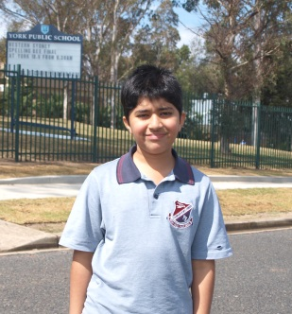There would be no one to stop all of thicilities, so the charities and things could try to stop just the bad segregation, or all segregation al

Dear Professor,

Thank you greatly for giving a lecture about ‘Human Rights’. It made me feel that Australia should work harder to make it a slavery-free and happy environment for everyone to be in. Our cheery class has thoroughly enjoyed your thoughtful presentation.

I also learnt that many people got killed or went to concentration camps because of who they were. The people were categorised in different groups such as disability people. Only the lucky ones were able to escape but not many of them did.

The stories you talked about were fascinating and interesting especially the one about the clever servant. I will try to learn more about human rights in the future.

I also never knew that Redfern was a convict’s name and I can’t believe that he moved on from a convict to a doctor.

Thankyou for the lecture.

Yun Yun

Dear Dr Sev. Ozdowski

First of all, I would like to thank you for presenting your talk on Human Rights to our classroom. Through your speech and the student’s answers, l learned many rights that we have in our world.

Through your speech, I learned you have to treat everyone the same even if they are different from you. I found it unfair how men treated women as weak and unable to do work. One thing that I still don’t understand is why you wanted to learn human rights and what you learn?

I am sure that everyone in my class enjoyed your speech just like how I did. Once again thank you for that inspiring lecture and I wish you a wonderful future.

Annet 

Dear Dr Sev

Thank you for visiting our class S3D on the 5th of May 2014 and helping us understand more about human rights.

I was excited to listen to what you were going to say before you even came in, because Mrs Dunstan had told our class that you were going to talk to us about human rights and how good you were.

You came in and started by asking us what countries we were from before you explained to us what human rights were. Someone said human rights was multiculturalism, while others said different things but you said it meant common values or common standards which helped me and probably other people to understand the meaning better, rather than a long string of words which would have been harder to comprehend.

Then you told us about how the United Nations was formed after the Second World War in result of the terrible things that happened in it. Like the concentration camps for example, in which over six million Jews and other innocent people died just because they had a different skin colour, race, culture or religion. People should not be discriminated because of that.

From your lecture I now know that it is important to treat everyone the same or many unpleasant things will happen. Your lecture has helped me understand more about this subject and I have learnt much more from you.

James He 

Dear Prof Sev,

When you stepped out into our classroom you immediately told me that you wanted to get your message across. You were able to make it a fun and enjoyable lesson that was very well prepared and presented. You made me realise how lucky I am to live in this country and how dangerous and horrifying other countries truly are.

You talked about rights and laws and compared the olden days to the present, the most heartbreaking story was about the camps and how they killed people in categories like how the Jewish were killed and then the homosexual and so on. Imagine you were a Jewish person, just being your normal-self having fun and just minding your own business then suddenly you are asked to pack your bags and go to one of these camps hoping to survive.

Thankyou for the awesome lecture.

Kind regards,

Mason Allen

To Dr Sev Ozdaski

As you entered, the room started to fill up with imaginative and creative thoughts as everyone realised this was the man that Mrs Dunstan was talking to us about. The man who presents lectures for children around Sydney and who would pull us in to thinking about the levels of human rights.

Everyone was intrigued into your world of human rights, as people started to answer more and more questions and answers. When you started the lecture, you asked everyone about their family background. And so everyone was intrigued into answering and telling a bit about their family. You now know that some people in my class come from India, England, China, Australia and other countries. I also now know you were born in Poland. Human rights is a big thing in the world and you explained it in the simplest form and I shall agree that the whole class thought so too. I actually never knew that there were so many forms of human rights and how bad it is in some countries. One example is that I knew Jews were killed by Germans but I never knew they killed 6 000 000 in WW2.

Some of the big names that pop up on the internet and books for humanitarians are Martin Luther King and Nelson Mandela. These special people helped others to be free and helped the poor to get better. They have spent their whole life helping others and caring about the poor and you explained this to us also.

Since your lecture today, you have influenced me to write this email to you. I hope in the future, you can give other schools, lectures about human rights and ask numerous questions to get their brains puzzled.

From Nickolas.

To Professor Sev Ozdoski,

I would like to start by thanking you for a brilliant lecture you brought before us. Not just I, but the whole class appreciates the effort you put in to not just prepare, but also deliver a lecture to fill our young, bewildered minds. I liked how you explained to us what horrible things happened in concentration camps, and how many people were affected by these selfish people. You showed us how important it is to have the humanitarian laws. These laws state that it doesn't matter what race, skin colour, religion, background or gender, you are just as good as everyone else. I am pleased that Australia is one of the most democratic countries going around, especially given we were the 2nd country to allow women to vote (after our neighbour New Zealand) and one of the first places with a minimum wage. I am also confused about what you said on Australia not having to look after our civil rights. I know for certain you made an impact on my life, and hopefully everyone else, so once more, THANK YOU SEV.

Dyson 

Dear Prof. Sev,

Does a difference in race, beliefs or gender decide what rights we have or dictate what we do? Should these differences be the cause of global prejudice or discrimination? NO!! Everyone has a will of their own, and they should be able express their feelings and opinions in an oppression free society! Why should we scoff at other's differences when we should be embracing our similarities? The world may hide behind a curtain of fake proclamations of world equality, but why not open them, and actually increase efforts towards that goal?

While I was trying to wrap my head around the thoughts zooming around my head in the ten misinterpreted minutes, the biggest one was: what would the lecture be like? A few opinions came to mind, well, that is until you walked through the door and shattered them all. Armed with just an attention grabbing accent, you won us over with your awe inspiring talk. You gave us a thorough history lesson on the founding of Human Rights and the United Nations starting from the severity of WW2 to the Constitution of Australia. From A to Z, from slavery to child rights; you covered every aspect of these little topics.

An egalitarian is not an occupation, nor should it be. What it must be, is in fact, a necessity! There are not enough pure-hearted people in the world as there is now, and we must change that. Why do we always see in films or read in books, that there is always a mean girl who picks on others; the coward who plays on others insecurities and differences? That is because it is true. We should work on eliminating these occurrences from the history books forever, arm in arm, hand in hand.

There is no such thing as a heartless person; while some may be colder than others, or more shrivelled up, everyone has one. Lives are only lived once, so it had better been a good one. Everyone deserves to be treated as an equal; an emotional, living, feeling being who has loved and lost, not just an object to be experimented on or killed just for the fun of it.. No one deserves to have lived without loving, or ever being loved at all.

Selina

To- Proffessor Sev Ordowski

On the 5th of May you visited our class to talk to us about Human Rights. Before you began your lecture you told us about your origin and asked some of the students about where their place of origin was. Once you had gotten to know a little bit about us you started your lecture.

One of the main things you mentioned to us was about concentration camps in World War 2 which was where people were categoriesed into groups and then made to do tasks.You told us that millions of people had died, as they were unable to do the work or were disabled and was unable to do such tasks. Another thing that you told us was that to many concentration camps were like slaughter houses and not many people came back out alive.

You soon told us about how the united nations were formed and how they all agreed to not to make seperate peace. Some of the most important things you talked to us about was that some countries think that Australia is disobeying the human rights by not letting Asylum Seekers in Australia and sending them into detention centres in places close by.This is important as a simple conflict can start a major war.

Another fact you pointed out was that Australia is one of the only countries that does not have an Bill of Rights. Though we have laws stating that children should be able to acess free education, women can vote and many more that makes sure that everyone is treated equally.

A point that you included into you speech, is that in some countries famillies are so poor that they sometimes have to sell their own children just to get money, this way the children don't get a chance to speak up for themselves and this is where human rights is essential as everyone should be able to express their own opinion and feel as if they are as important as anyone else in the world.

I would like to thank greatly for comming into the class to talk about Human Rights. I have enjoyed you lecture greatly and hope that others did too. I hope that you will keep on going to other schools and talking to them about human rights as they will greatly enjoy it, just as much as I have.

Sincerely -Jinuki

Dear Dr Sev,

The informative lecture you presented was as good as one can get. I could imagine life at the concentration camps, during WW1, before human rights took place.

Your inspiring lecture had filled me with thoughts that my brain wouldn’t have wandered across, and even if it did pick it up on the streets, it wouldn’t have the same quality of information that you presented to our class. From the facts about the Jews getting killed, the prisoners of war getting slaughtered and the concentration camps, the elderly and the disabled forced to be killed, to the positive facts about human rights that have saved millions from being executed.

Thank you for giving your time to make this trip to our school. I hope you come back again next year to give the future year 6OCs the same experience that our class had today.

Sincerely, Eric



Dear Sev

Thank you for your inspiring lecture on human rights yesterday. Your lecture had so much information, I nearly ran out of room in my book to take points down.

It is sad to know that the Russians and Germans were being really mean to the prisoners in the concentration camps and also how they made them work for them, test weapons on them and killed them whenever they wanted.

Everybody has freedom of speech and political rights. Interestingly, Australia was one of the first to have women’s rights, which gave women the opportunity to vote.

It is still not fair that many children in third world countries are forced to work at a young age especially when they are supposed to be going to school. The children in Australia are very lucky to be able to go to school.

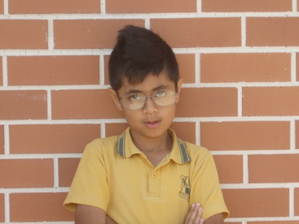The provision of human rights makes sure that everyone is treated equally and has equal opportunities regardless of age, gender or race.

Taaj

Email to Sev Odozoski

Thank you for giving me an opportunity to watch and learn from a thrilling adventure in the field of human law and rights. I will guarantee that the whole class enjoyed watching your intriguing yet sophisticated lecture well and thoroughly.

My favourite part of your lecture is when you talked about your family’s experience and World War Two and its involvements and concerns of racial prejudice, women’s rights, children’s rights and discrimination. Not only was I intrigued, but I was surprised to know that all our humanitarian work was to prepare me to overcome any question that you may throw at me and believe me it worked! I was speechless when I found out that I was living in a country with no civil freedom as well as finding out that there is still a sliver of slavery in the world today.

I also liked the discussion on China and North Korea and how stupid laws can be, like if you wanted to be participating in university in North Korea, you must have the same haircut as their president Kim Jong-Un.

Ultimately, I must thank for giving the most wondrous, remarkable, intriguing…… lecture/adventure I have ever experienced in my life.

Sincerely,

Kevin Kuriakose

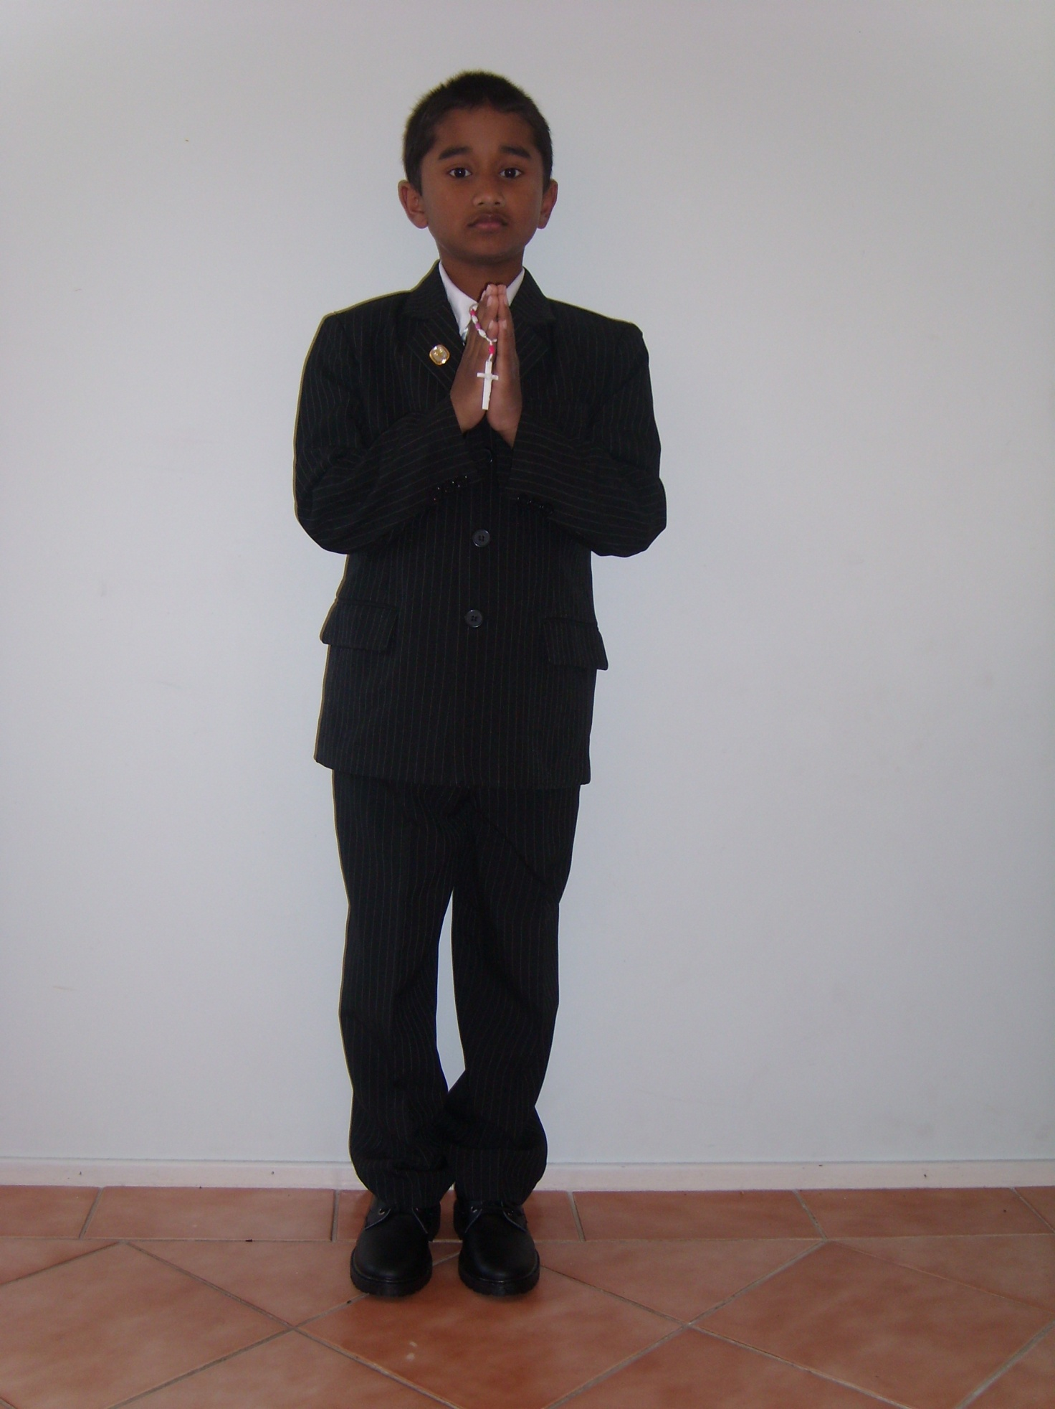

Dear Prof Sev,

Your exquisite lecture was truly something to behold; very informative and meaningful. The components of your lecture were well thought-out, like linking the UN with the World War 2. Colossal amounts of facts have been exerted into my brain, like how Canberra came to be.

You also informed us about the Nazis and concentration camps. The Nazis were very cruel people, killing every Jew in sight. Unfortunately, the Polish people were used as slaves at the middle of the crisis; one foot wrong, then bang. As the World War 2 concluded, a group called the UN (United Nations) started setting new laws. This group is still going strong, installing new rules every time. You expressed your feelings about Human Rights in such a remarkable way, that it captured us in a trance. It was amazing that New Zealand was the first country to allow women to vote and Australia was in fact the second. I processed so much information that my brain was about to explode. There is still slavery in the world. This issue is coming up too much and this should be dealt with; your lecture helped me realise that slavery should be gone for good.

In conclusion, your lecture was enjoyed by the whole class, I believe, and I feel very happy to stand next to a worker for the UN. Your mind-boggling facts will be very helpful for me, I think, for the future. I have truly learnt a lot from you.

Rafid

Email to Sev

I would first like to thank you for your marvellous lecture about Human Rights. The way you captivated us at the very start by asking where we were from, then linking that to human rights was amazing.

The way you involved us in the lecture was superb everyone was eager to hear your next word. Also how you told us that Redfern was a convict and he became a medical doctor was brand new to us. Your lecture was a thing to remember because you had a different approach and you did not use the white board that was also new.

Thank you again for your wonderful lecture on human rights and hopefully I can hear your lecture again sometime soon.

Sakshyam



Dear Prof Sev,

What I was expecting to see in your lecture was what lots of humanitarians and people like you use, which is passion, and I was right because your lecture was filled with it. We could all tell how serious the situation was and we could also tell how hard you thought the lecture through. And not only did you use passion, but you used something that I learnt at National Young Leaders Day which was empathy. You used it, but also made us use it by telling us all the things people went through in times when wars were still happening.

Then you brought up the topic of human rights. You told us how badly people were treated during the war time, so when the war ended they started to come up with the idea of human rights. However, the law wasn't passed until the cold war started to emerge. When that was all cleared up, you asked us what we thought about human rights. soon after you asked us if slavery was still around a majority of the class said no, but to our surprise, we were proved wrong. This really opened my eyes. I often didn't think much of slavery as I thought it was gone.

I was also REALLY shocked when you gave us the certificate for our class, because I thought ''hang on, this guy is coming in to teach us in his own time and help us, yet we are the ones getting the certificate!'' In my eyes, you deserved that certificate.

Jarrod 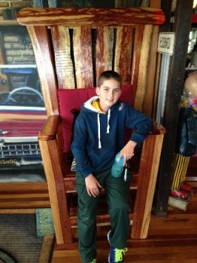

Dear Doctor Sev Ozdowski,

I believe your lecture was one of my favourites. I never knew that there were so many things wrong with the world and we would need so many different rights.

I have learnt so many new things from you. I didn’t even know slavery existed in modern times. Segregation was a new word to me; I learnt that segregation is used in different ways, for good and bad.

One of the main tings you spoke about was rights, and half of them I’ve never even heard of. A thing I would like to know is, which human right is the most important?

Overall, I would like to thank you for an amazing lecture. I enjoyed hearing all your stories such as how Canberra got its name.

Sunita



Dear Professor Doctor Sev Owdoaski,

Thank you for your lecture on Human Rights. You began the talk by asking our class what country our family came from. Some of the answers were New Zealand, Germany, India, England and many more interesting places. After that, you began to talk about some of the rights we have. Children’s rights, freedom of speech, economic rights, women’s rights, political, social and civil rights and many more. The first country to have women’s rights was New Zealand! Australia was second.

Concentration camps were extremely bad. My grandad went to England and when he was there, he went to an ex-camp. He saw all the belongings that were taken from these poor people. He even saw the hair that was pulled off their bodies. It made me almost cry when I saw the photo of the belongings, I couldn’t see the photo of the hair it just sounds too horrible. I wouldn’t EVER want to be in a Concentration Camp. The horror!

The most amazing thing you said in your lecture was about Australia and how it doesn’t actually have a Bill of Rights! Thank you greatly for coming to talk to our class about Human Rights. We appreciate your time and effort. Your lecture is my favourite by far!

Tammin Danby 

Dear Doctor Sev Ozdaski,

Your lecture was quite fascinating to not only me, but the rest of the class. We all thoroughly enjoyed it.

You spoke about the rights humans own. They are to do with women’s rights, political, child, economic, social and human rights. The things I have mentioned are powerful rights to own. How, you may ask. Let me explain.

Women’s rights make women able to have a job be allowed to vote and most importantly be treated equally to men. The reason women were not treated equally to men was because men thought women were weak, but women have proved they can have job anywhere, even in the military.

Political rights make it so people have a right to vote, to vote on who is their Prime Minster, President etc.

Child rights are about things like being able to have an education. That means, that children can learn to read and write, unlike many children in older times. Economic rights means someone can earn enough money so that they could be financially stable. Social rights is about the freedom to speak. Human rights is a summary of all of the above.

Human rights are an amazing thing that everyone should celebrate and appreciate. Everyone should have the privilege to be treated with respect, no matter what age or what race.

Yours sincerely, Sarah 

Dear Dr. Prof. Sev Ozdaski

My fellow peers and I would like to thank you for an amazing thought-provoking lecture on the concepts and purposes behind the human rights laws and rulebooks.

You also talked about how even though we all come from different countries, we are all now Australians and we need to work together with not just the people we call ‘Australians’, but with everyone so we can make this state or country a better place for the people who live in it and for the tourists from around the world. We as a class talked about the remarkable things you included in your lecture and how you didn’t leave a single thing unexplained. I furthermore appreciated how you told us not to pick a job we don’t want to do, because even though sometimes even the job we thought we would have loved can be boring, we are still meant to have a little fun every now and then. I cannot thank you enough for your brilliant lecture on human rights.

Jack 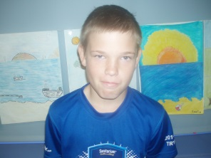

Dear professor Sev. Ozdowski

Ozdowski. Ozdowski? Where-ever you were from it wasn’t England. I like listening to people from foreign countries, mostly because they have awesome accents, but they do have very interesting stories of their native place. Human Rights? Now I had heard that before. Mostly from old windy politicians talking about something overseas that I didn’t understand, but this was going to be like the other lectures. Interesting! Not about the Russian oyster trade.

One of the first questions you asked us was ‘where are you from?’, wait, what’s that got to do with human rights? You explained. We are all the same. Just because someone has dark skin, does not mean they came from outer space. Unfortunately the ‘Nazis’ had obviously not been told this, especially when they started killing people in concentration camps by using them as guinea pigs for all new weapons and gases.

I found the information about the land were Canberra now stands very interesting.

Thankyou: Bethany 

Dear, Dr Sev Ozdowski,

Your topic was Human Rights. We have all heard about it before, but the way you presented it caught the attention of the whole class, including Mrs Dunstan because it was not on the white board.

There were serious and funny parts in your talk. The presentation has had a massive effect on the way I look at Human Rights and how much we care about the world. Human rights have many different outcomes depending on what right should be noticed in your opinion.

We discovered that Mrs Dunstan’s Mother was the founder of Year of The Child which I believe should still be celebrated not because I’m a child but because it brings joy to the children that are poor or live in third world countries that no one cares about.

Racism and sexism are similar in a way because it is discrimination about how you look, where you come from, what religion you have or the way you speak. Racism is leaving or pushing someone away because of their background, skin colour or if they are too weak to play the game you are playing. I have been a victim of racism myself because I have a lighter skin colour and I’m aboriginal. Sexism on the other hand, is saying a woman cannot have a job in the mining industry, but then a woman has been so successful, she becomes rich. It’s almost like saying boys can’t knit but my Year Two class did French knitting and the boys did it more often than the girls.

In one other email, the lecturer asked what our dream job was, and my one was to become famous and then start a fundraiser called ‘We are all stars’ to help women, children and troubled people and families reach their goal in life.

Thank you, Kobi 

Dear Prof Sev,

I would like to say thankyou for your lecture. Human rights is a necessity to the human race. Not giving people of other races proper rights, is just plain wrong. Not having human rights would mean that many people around the world would be in slavery and poverty. Just because someone looks different to you, doesn’t mean they are a lesser people. The work that the U.N. does, has helped many poor people around the world. But I do get angry when Human rights laws get breached in countries like Korea. I just wish human rights were introduced earlier. Then they would have been able to prevent Adolf Hitler from mass murdering 6 000 000 innocent Jewish people.

Although human rights such as woman rights, children’s rights, economic rights and many other different rights, are used in different countries, they are often broken and tossed away. THEY SHOULD NOT BE NEGOTIABLE. Everyone and I mean EVERYONE, should be allowed basic human rights.

Yours sincerely,

Aidan 